


Business Valuation
Basics of compounding, discounting, basic valuation of the present value model

Table of Contents
How to calculate present values 5
IMPORTANT TERMS 5
Calculating Future Values 7
Calculating Present Values 9
Valuing an Investment opportunity 11
Net Present Value 13
Risk and Present Value 15
Present Values and Rates of Return 17
Calculating Present Values when there are multiple cash flows 18
The Opportunity Cost of Capital 20
Perpetuities and Annuities 22
How to valuate Perpetuities 22
How to Value Annuities 24
Differences between Annuity and Perpetuity 25
Valuing Annuities Due 26
Calculating Annual Payments 27
Future Value of Annuity 32
Growing Perpetuities and Annuities 34
Growing perpetuity 34
Growing annuity 35
How interest is paid and quoted 37
Continuous Compounding 39

How to calculate present values
Companies make several investments. Some of them are tangible assets (or things you can physically kick) including buildings, equipment, and factories. Some assets are intangible, like patents or trademarks. In each instance, the business invests some money now in the anticipation of earning more later. Investments are also made by individuals. For instance, the annual cost of your college education can be 40 000€. You expect that your investment will pay off in the shape of a larger wage in the future. You are currently reaping while still sowing. Companies raise capital to pay for their investments, taking on obligations in the process. For instance, they might promise to borrow money from a bank and pay it back with interest later. Another possibility is that you took out a loan to finance your investment in a college degree with the idea of returning it with money from your future salary.
All of the problems in this chapter are presented simply in euros, but the computations and principles are the same if they are presented in dollars, Japanese yen, or Mongolian tugrik.

IMPORTANT TERMS
Annuity – it is a stream of payments made at equal intervals (e.g. at the end of each year). An annuity is an asset that pays a fixed sum each year for a specified number of years. The equal-payment house mortgage or instalment credit agreement are common examples of annuities.
Annuity due – is a type of annuity in which the first payment is payable right away at the start of each term.
Compound interest –is the interest you earn on interest.
Discount cash flow is a method for valuing investments that calculates the value of an investment based on expected future cash flows. Using estimates of how much money an investment will make in the future, DCF analysis seeks to evaluate the value of an investment today.
Discount factor –a decimal number discounted back to its present value by a cash flow value.
Future Value – is a current asset's value at a future time depending on an expected growth rate.
Growing annuity – a series of payments or revenues that increase each period by a certain percentage over a predetermined number of periods. Payments or receipts occur at the end of each period in a growing ordinary annuity while at the beginning of each period in a growing annuity due.
Growing perpetuity – is a stream of payments predicted to increase continuously throughout an unlimited number of periods.
Net present value – the difference between the present value of cash inflows and outflows over a time period. To evaluate the profitability of a proposed investment or project, NPV is used in capital budgeting and investment planning.
Perpetuity – a type of annuity that lasts forever, into perpetuity. The stream of cash flows continues for an infinite amount of time.
Present Value – is the value at the present time of a future financial asset or stream of cash flows at a specific rate of return.
Rate of return – is a percentage of an investment's starting cost that represents the investment's net gain or loss over a given time period.

Calculating Future Values
Interest can be earned by investing money. Therefore, if given the option to choose between 100€ today and 100€ in a year, you will obviously choose the money today in order to earn interest for that year. When financial managers mention the time value of money or cite the most fundamental tenet of finance, "A dollar now is worth more than a dollar tomorrow," they are making the same point.
Suppose you invest 100€ in a bank account that pays interest of $r$ = 7% a year. In the first year, you will earn interest of 0,07 * 100€ = 7€ and the value of your investment will grow to 107€:
$$Value of investment after 1 year=100€*\left(1+0,07\right)=100*1,07=107€$$
By investing money for a year, you give up the opportunity to spend 100€ today, but gain the chance to spend 107€ next year.
If we leave money for a second year, you earn interest of 0,07 × 107€ = 114,49€:
$$Value of investment after 2 years=107€*1,07=100*{1,07}^{2}=114,49€$$
Today |  | Year 2
100€ | × ${1,07}^{2}$ | 114,49€
Notice that in the second year, you earn interest on both your initial investment (100€) and the previous year’s interest (7€). As a result, your wealth grows at a compound rate and the interest that you earn is called compound interest.
$$FV=PV*{(1+r) }^{t}$$
where FV – Future Value
PV – Present Value
$r$ – interest rate per year
t – total number of years

Example 1. You invest 100€ in a bank account that pays interest of $r$ = 10% a year for 20 years. Also, you invest 100€ with interest $r$ = 5% a year for 20 years. Calculate future values for both investments.
$$FV_{1}=100€*{\left(1+0,1\right)}^{20}=672,75€$$
$$FV_2=100€*{\left(1+0,05\right)}^{20}=265,33€$$
As we can see from the Example 1, the higher the interest rate, the faster your savings will grow.

Calculating Present Values
In previous paragraphs, we were calculating the Future Value (FV) of investment. Let’s turn this around and ask how much we need to invest today to produce 114,49€ at the end of the second year. In other words, what is the Present Value (PV) of the 114,49€ payoff? You can just run the future value calculation in reverse and divide the future payoff by ${1,07}^{2}$:
$$Present Value= \frac{114,49€}{{1,07}^{2}}=100€$$
Today |  | Year 2
100€ | ÷ ${1,07}^{2}$ | 114,49€
In general, suppose that you will receive a cash flow of $C_{t}$ euros at the end of the year t. The present value of this future payment is:
$$PV= \frac{C_{t}}{{(1+r) }^{t}}$$
where PV – Present Value
$C_{t}$ – Cash flow at the end of year t
$r$ – interest rate per year
t – total number of years
The rate $r$ in the formula is called the discount rate, and the present value is the discounted value of the cash flow $C_{t}$. Some authors write the present value formula differently. Instead of dividing the future payment by ${(1+r) }^{t}$ we can multiply the payment by the discount factor
$$DF=\frac{1}{{\left(1+r\right)}^{t}}$$
The discount factor measures the present value of one euro received in year t.
For example, with an interest rate of 7% the 2-year discount factor is:
$$DF_{2}=\frac{1}{{\left(1+0,07\right)}^{2}}=0,8734$$
Investors are prepared to pay 0,8734€ today in exchange for the delivery of 1€ in two years. If each euro received in year 2 is worth 0,8734€ today, then the present value of your payment of 114,49€ in 2 years must be:
$$PV=DF_{2}*C_{2}=0,8734*114,49=100€$$

Example 2. Calculate the present value of an investment for 20 years if the future value is 100€, and the interest rate is 5% per annual. Calculate the present value for the same amount of future value with the same investment period if interest rate will increase to 10%
$$PV_{1}=100€*\frac{1}{{\left(1+0,05\right)}^{20}}=37,69€$$
$$PV_{2}=100€*\frac{1}{{\left(1+0,10\right)}^{20}}=14,86€$$
If the interest rate increases to 10%, the value of the future payment falls by about 60%.
As we can see from the Example 2, the longer you have to wait for your money, the lower its present value.

Valuing an Investment opportunity
How do you determine whether it is worthwhile to pursue an investment opportunity? Let's say you run a small business that is thinking of building an office complex in a suburban area. The price of purchasing the land and building is 700 000€. Construction financing is possible because to the company's cash on hand. Your real estate advisor anticipates a lack of office space and projects that you can sell your property for 800 000€ in the upcoming year. We'll start out by assuming that this 800 000€ is a sure thing for the sake of simplicity.
The rate of return on this one-period project is easy to calculate:
$$Rate of return=\frac{expended profit}{required investment}$$
In our case rate of return will be calculated as expended profit (800 000€ – 700 000€) divided by the required investment (700 000€):
$$Rate of return=\frac{800 000€-700 000€}{700 000€}=0,143 or 14,3\%$$
You can invest money to the project or pay shareholders cash so they can contribute money on their own. We suppose that by investing for a year in secure assets, they can get a 7% profit (U.S. Treasury debt securities, for example). Or they can make riskier but 12%-returning investments in the stock market. Which is higher, 7% or 12% in terms of the opportunity cost of capital? The answer is 7%. The shareholders of your organisation may earn that rate of return by making their own investments at an identical level of risk as the proposed initiative. Here, there is no risk at all. (Remember, for now, we are presuming that the office building's future value is known with confidence.) Because the investment project provides a safe return of 14% rather than the market's safe return of only 7%, your shareholders would vote unanimously in favour of it.
The initiative to build an office building is consequently approved, but how much is it worth and how much will the investment increase your wealth? At the conclusion of a year, the project generates a cash flow. We reduce the cash flow by the opportunity cost of capital to determine its present value:
$$PV=\frac{C_{1}}{1+r}=\frac{800 000€}{1+0,07}=747 664€$$
Let's say you decide to sell your project as soon as you have purchased the site and paid for the building. How much could it possibly sell for? That question is simple. Your property should be valued at its PV of 747 664€ if the investment will guarantee a return of 800 000€.
Investors in the financial markets would have to pay that to receive the same future reward. There wouldn't be any buyers if you tried to sell it for more than 747 664€ because the property's expected return would be less than the 7% offered on government securities. You could always sell your house for less, but why would you want to do that when the market will bear it? The only possible price that satisfies both the buyer and the seller is the 747 664€ present value. The property's market price is therefore equal to its present worth.
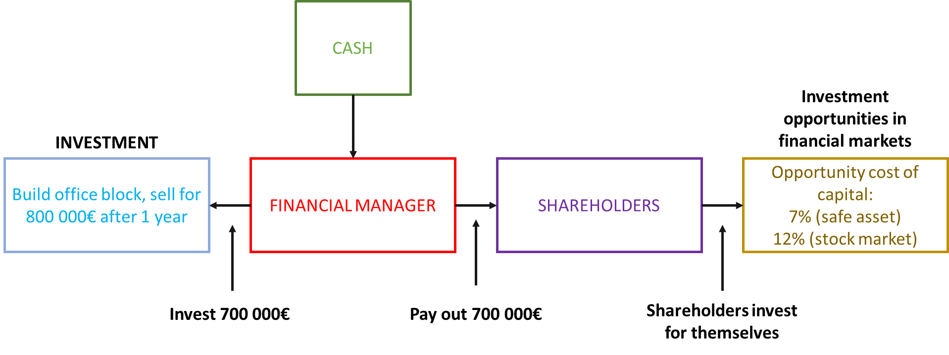
Figure 1: Investment opportunities

Net Present Value
Despite the fact that the office building is now valued 747 664€, you are not necessarily in a better financial position. Considering that you invested 700 000€, the net present value (NPV) is 47 664€. Net present value equals present value minus the required investment:
$$NPV=PV-investment$$
In our case it will be:
$$NPV=747 664€-700 000€=47 664€$$
In other words, the value of your office development exceeds the cost. It contributes positively to value and raises your worth overall. The formula for calculating the NPV of your project can be written as:
$$NPV=C_{0}+\frac{C_{t}}{1+r}$$
where NPV – Net Present Value
$C_{0}$ – cash flow at time 0 (usually a negative number)
$C_{t}$ – cash flow at time t
r – interest rate per year
In our example:
$$NPV= -700 000€+\frac{747 664€}{1+0,07}=47 664€$$
When cash flows occur at different points in time, it is often helpful to draw a timeline showing the date and value of each cash flow.
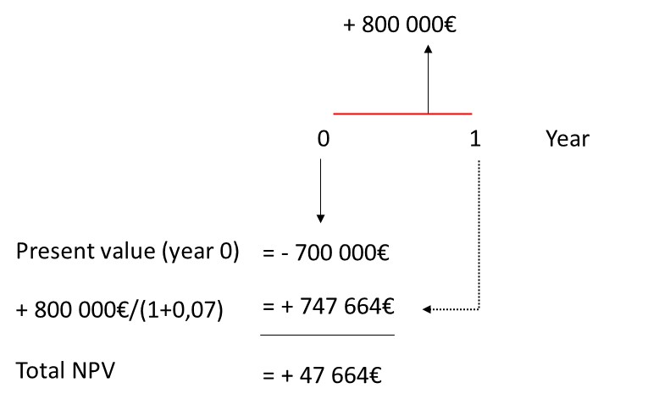
Figure 2: Timeline of cash flows
It is important to remember that present value is the investment's value as of right now, and net present value is the contribution the investment provides to your wealth.

Risk and Present Value
In our discussion of the office construction, one incorrect assumption was made: Your real estate advisor cannot be guaranteed of the profitability of an office complex. The best projection is those future cash flows, but they cannot be relied upon.
Your NPV calculation is incorrect if there is uncertainty in the cash flows. Investors would not purchase your building for 747 664€ since they could obtain those cash flows with certainty by purchasing 747 664€ of U.S. government securities. In order to pique the interest of investors, you would have to lower your asking price.
Here, we may apply a second fundamental financial rule: A safe dollar is worth more than a risky dollar. The majority of investors avoid taking on riskier projects and won't do so unless they anticipate a larger return. For risky ventures, the ideas of present value and the opportunity cost of capital nevertheless make sense. It is still appropriate to reduce the reward by the rate of return provided by an investment with a comparable level of risk in the financial markets. But we also need to consider anticipated returns and rates of return on other investments.
Investments vary in their level of risk. The office development is more risky than a government security but less risky than a start-up biotech venture. Consider that you think the initiative carries the same level of risk as a stock investment, with a 12% expected return. The opportunity cost of capital for your project is 12% then. By choosing to invest in the office building rather than assets that carry an equivalent level of risk, you are giving that up.
Now recompute NPV with r = 12%
$$PV=\frac{800 000€}{1+0,12}=714 286€$$
$$NPV=741 286€-700 000€= 14 286€$$
The office building still adds value net, but the rise in your wealth is less than in our first calculation, which made the assumption that the project's cash flows would be risk-free.
As a result, the time and risk of the cash flows determine the value of the office property. If you could get it now, the 800 000€ payoff would be worth just that. The delay in cash flow decreases value by 52 336€ to 747 664€ if the office building is as risk-free as government assets. The risk further lowers value by 33 378€ to 714 286€ if the building is as hazardous as a stock market investment.
Unfortunately, it is sometimes more difficult than our example shows to account for time and risk in asset valuations. We therefore consider the two effects independently.

Present Values and Rates of Return
Since the office building will be more valuable than it will cost to build, we have determined that doing so is a reasonable decision. We calculated its value by asking how much you would need to put directly in equities to get the same return. For this reason, we reduced the projected return by the rate of return on these instruments with comparable risks—in our case, the entire stock market.
Our decision rule can also be expressed as follows: The rate of return on your real estate business is worthwhile since it outweighs the opportunity cost of capital. The profit as a percentage of the initial investment is what determines the rate of return:
$$Return=\frac{Profit}{Investment}$$
In our case:
$$Return=\frac{800 000-700 000}{700 000}=0,143 or 14,3\%$$
The return lost by not investing in the financial markets is once again the cost of capital. The loss of return is 12% if investment in an office building is as risky as stock market investing.
You should move on with the project since the 14.3% return on the office building outweighs the 12% opportunity cost.
Even though the payoff is just as risky as the stock market, building the office building is a wise decision. The following two rules can be used to support the investment:
- Net present value rule – accept investment that have positive net present values.
- Rate of return rule – accept investment that offer rates of in excess of their opportunity cost of capital.

Calculating Present Values when there are multiple cash flows
The fact that present values are all expressed in current currency makes them easy to add up. Alternatively stated, the present value of the cash flow (A + B) is the sum of the present values of the two cash flows.
Consider the scenario where you want to estimate the worth of a stream of future cash flows. The entire present value is, according to our rule for adding present values, as follows:
$$PV=\frac{C_{1}}{1+r}+\frac{C_{2}}{{\left(1+r\right)}^{2}}+\frac{C_{3}}{{\left(1+r\right)}^{3}}+…+ \frac{C_{T}}{{\left(1+r\right)}^{T}}$$
This is called discounted cash flow (DCF) formula. We can to write it as:
$$PV= \sum_{t=1}^{T}{\frac{C_{t}}{{\left(1+r\right)}^{t}}}$$
where Σ refers to the sum of the series of discounted cash flows. To find the net present value (NPV) we add the (usually negative) initial cash flow:
$$NPV=C_{0}+PV=C_{0}+\sum_{t=1}^{T}{\frac{C_{t}}{{\left(1+r\right)}^{t}}}$$

Example 3. Your real estate adviser has come back with some revised forecasts. He suggests that you rent out the building for two years at 30 000€ a year, and predicts that at the end of that time you will be able to sell the building for 840 000€. For this case $r = 12\%$
Thus there are now two future cash flows — a cash flow of $C_{1}=30 000€$ at the end of one year and a further cash flow of$C_{2}=30 000+840 000=870 000€$ at the end of the second year. The present value of your property development is equal to the present value of $C_{1}$ plus the present value of $C_{2}$.
By using the rule for adding present values we can calculate the total present value as:
$$PV=\frac{C_{1}}{1+r}+ \frac{C_{2}}{{\left(1+r\right)}^{2}}=\frac{300 000}{(1+0,12)}+\frac{870 000}{{\left(1+0,12\right)}^{2}}=26 786+69 559=720 344€$$
It looks as if you should take your adviser’s suggestion. NPV is higher than if you sell in year 1:
$$NPV=720 344-700 000=20 344€$$
We can also draw a time line for better visualization (see Figure 3).
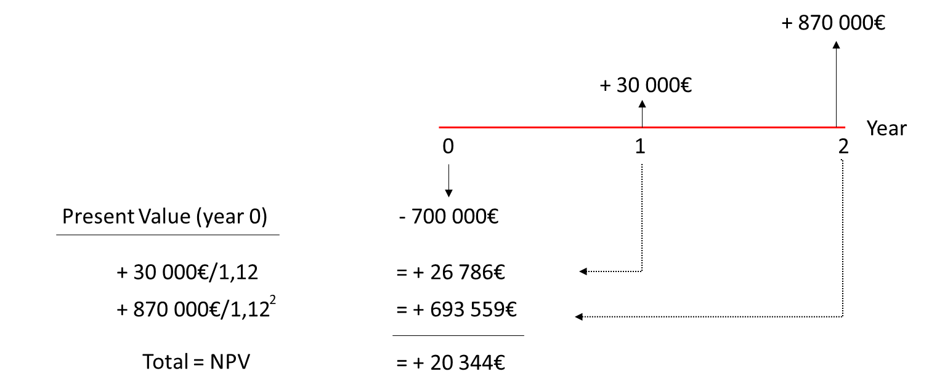
Figure 3: Timeline of example

The Opportunity Cost of Capital
By making an investment in the office building, you forfeit the chance to profit from the stock market's anticipated 12% return. Therefore, 12% represents the opportunity cost of capital. You are determining how much investors in the financial markets are willing to pay for a security that generates a similar stream of future cash flows when you discount the predicted cash flows by the opportunity cost of capital. Your calculations showed that for an investment that generates cash flows of 30 000€ in year one and 870 000€ in year two, these investors would need to pay 720 344€ in total. As a result, they won't offer you any more for your office complex.
Discussions regarding the cost of capital may introduce confusion. Imagine a banker walking up. She remarks, "Your business is a good and secure one with little debts. You may get the 700 000€ loan from my bank for the office building at an 8% interest rate. This implies that the cost of capital is 8%, right? If so, it would make the initiative even more valuable. With a capital cost of 8%, the PV would be:
$$PV=\frac{30 000}{1+0,08}+\frac{870 000}{{\left(1+0,08\right)}^{2}}=773 663€$$
and the NPV would be:
$$NPV=773 663-700 000=73 663€$$
However, that can't be true. First off, the loan's interest rate has nothing to do with the project's risk; rather, it measures how well your current business is doing. Second, whether you accept the loan or not, you will still need to decide between purchasing the office building and making an equally risky stock market investment. If a corporation or its shareholders can borrow money at 8% and make an equally risky investment in the stock market that offers a larger return, then a financial manager who borrows 700 000€ at 8% and invests in an office building is not smart, but dumb. Because of this, the 12% anticipated return on the stock market represents the capital opportunity cost for your project.

Perpetuities and Annuities

How to valuate Perpetuities
On occasion, the British and the French have been known to disagree and sometimes even to fight wars. The British consolidated the debt they had issued throughout these wars at the conclusion of certain of them. Consuls were the name given to the securities issued under such circumstances. Consuls exist for all time. These bonds provide a set income for every year in eternity but are not obligated to be repaid by the government. In spite of the passage of time, the British government continues to pay interest on consolation bonds. The annual payment promised divided by the present value represents the perpetuity's annual rate of return:
$$Return=\frac{Cash flow}{PV}$$
$$r=\frac{C}{PV}$$
We can obviously twist this around and find the present value of a perpetuity given the discount rate $r$ and the cash payment $C$:
$$PV=\frac{C_{1}}{1+r}+ \frac{C_{2}}{{\left(1+r\right)}^{2}}+ \frac{C_{3}}{{\left(1+r\right)}^{3}}+…$$
Let $\frac{C}{1+r}=a$ and $\frac{1}{1+r}=x$. Then we have (1)
$$PV=a(1+x+x^{2}+…)$$
Multiplying both sides by $x$, we have (2)
$$PVx=a\left(x+x^{2}+…\right)$$
Subtracting (2) from (1) gives us
$$PV(1-x)=a$$
Therefore, substituting for $a$ and $x$
$$PV \left(1-\frac{1}{1+r}\right)=\frac{C}{1+r}$$
Multiply both sides by $1+r$ and rearranging gives
$$Present Value of perpetuity=PV=\frac{C}{r}$$

Example 4. The year is 2030. You have been fabulously successful and are now a billionaire many times over. It was fortunate indeed that you took that finance course all those years ago. You have decided to follow in the footsteps of two of your philanthropic heroes, Bill Gates and Warren Buffett. Malaria is still a scourge and you want to help eradicate it and other infectious diseases by endowing a foundation to combat these diseases. You aim to provide 1 billion EUR a year in perpetuity, starting next year. So, if the interest rate is 10%, you need to write a check today for.
$$Present Value of perpetuity=\frac{C}{r}=\frac{1 000 000 000}{0,10}=10 000 000 000=10 billion EUR$$

WARNINGS. First of all, the formula is easily mistaken for the current value of a single payment at first glance. The present value of a 1€ payment at the end of a year is $1/(1 + r)$. The eternity is worth $1/r$. These are really dissimilar. The perpetuity formula, in addition, provides the value of a consistent stream of payments beginning one period from now. Therefore, the foundation would get its first payment from your 10 billion EUR endowment in a year. You must spend an additional 1 billion EUR if you also wish to give a sum of money.
It's occasionally necessary to determine the value of a perpetual that won't start paying out for a while. For example, let's say you want to make the first payment in four years at the rate of 1 billion EUR annually. Figure 4 provides a timeline of these payments.
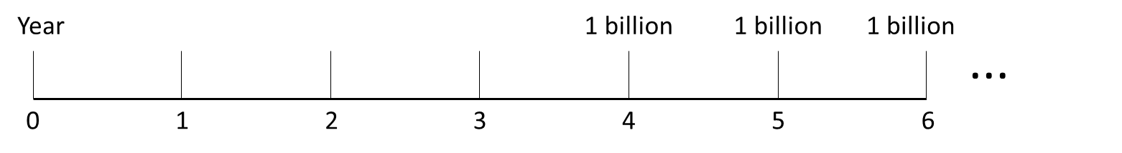
Figure 4: Perpetuity with a series of payments starts from year 4
Consider their future worth in year three first. The endowment will thereafter become a regular perpetuity, with the first payment due at the end of the calendar year. Therefore, according to our perpetuity formula, the endowment will be worth in year 3.
$$\frac{1 billion}{r} =\frac{1 billion}{0,1} = 10 billion EUR$$
But its value has decreased with time. We need to multiply by the three-year discount factor to determine the value today.
$$\frac{1}{{(1 + r)}^{3}} = \frac{1}{{(1 + 0,1)}^{3}}=0,751$$
Thus, the “delayed” perpetuity is worth $10 billion EUR*0,751 = 7,51 billion EUR$. The whole sum is as follows:
$$PV=1 billion EUR*\frac{1}{r}*\frac{1}{{\left(1 + r\right)}^{3}}=1 billion EUR*\frac{1}{0,1}*\frac{1}{{\left(1+0,1\right)}^{3}}=7,51 billion EUR$$

How to Value Annuities
An annuity is an asset that pays a fixed sum each year for a specified number of years. The equal-payment house mortgage or instalment credit agreement are common examples of annuities.
Annuities may always be valued by figuring out the worth of each cash flow and adding them up. However, it is often quicker to use a simple formula that states that if the interest rate is r, then the present value of an annuity that pays C a period for each of t periods is:
$$Present Value of t-year annuity=C\left[\frac{1}{r}-\frac{1}{r{\left(1+r\right)}^{t}}\right]$$
The expression in brackets shows the present value of 1€ a year for each of t years. It is generally known as the t-year annuity factor.

Differences between Annuity and Perpetuity
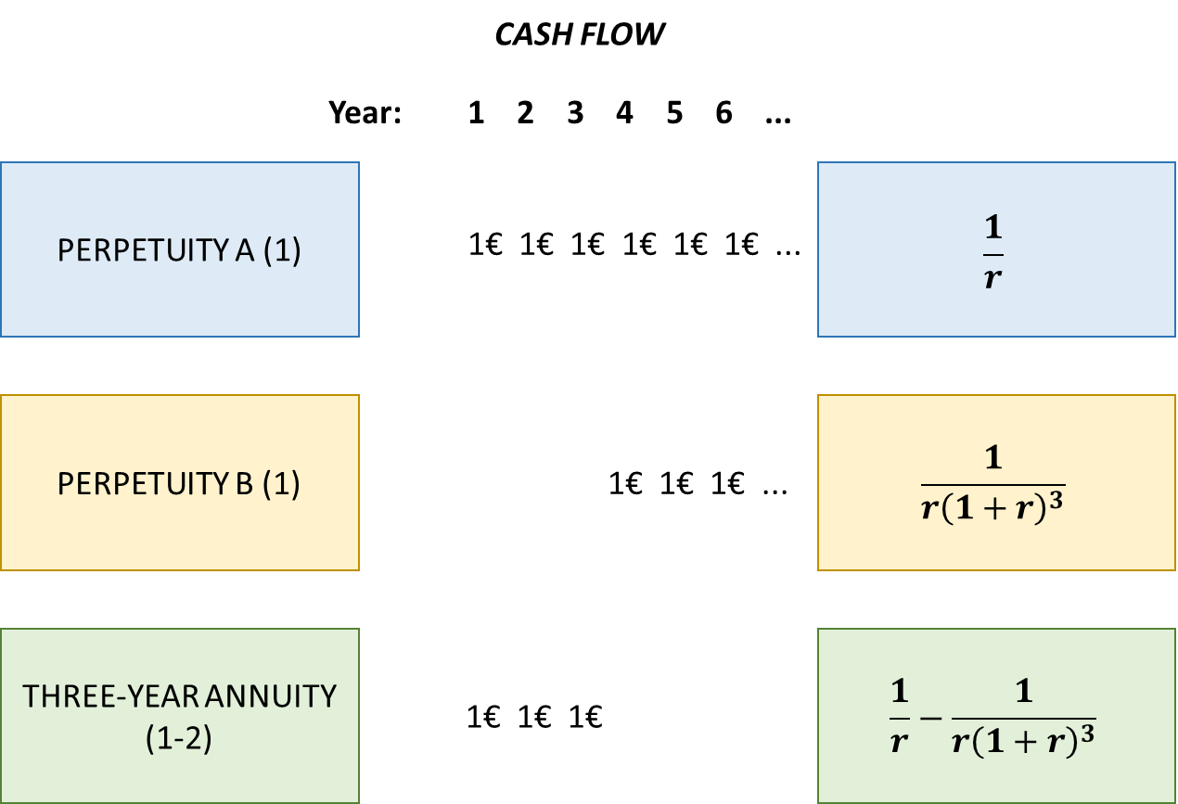
Figure 5: Differences between perpetuity and annuity
ROW 1. The investment provides a perpetual stream of 1€ starting at the end of the first year. So, the present value of this perpetuity is:
$$PV=\frac{1}{r}$$
ROW 2. The investment provides a perpetual stream of 1€ starting at the end of the fourth year (payments do not start until year 4). To calculate the present value of this perpetuity we simply multiply $\frac{1}{r}$ (started at year 3) by 3-year discount factor $\frac{1}{{\left(1+r\right)}^{3}}$.
$$PV= \frac{1}{r} * \frac{1}{{\left(1+r\right)}^{3}}=\frac{1}{r{\left(1+r\right)}^{3}}$$
ROW 3. The investment provides a level payment of 1€ a year for each of three years (it is a 3-year annuity). The investments in rows 2 and 3 produce the exact same cash pay-outs as the investment in row 1, as can be seen from the Figure 5. The value of our annuity (row 3) must therefore be the same as the value of the row 1 perpetuity less the value of the delayed row 2 perpetuity:
$$PV= \frac{1}{r}-\frac{1}{r{\left(1+r\right)}^{3}}$$

Valuing Annuities Due
When a payment is due at the start of a term, it is known as an annuity due. Even while the difference may appear small, it can have a big influence on your entire debt or savings. To calculate the Annuity due we can use formula:
$$Annuity Due=PV of t-year annuity*\left(1+r\right)= C\left[\frac{1}{r}-\frac{1}{r{\left(1+r\right)}^{t}}\right](1+r)$$

Example 5 – Coasting an Instalment Plan. Most instalment plans call for level streams of payments. Suppose that Tiburon Autos offers an “easy payment” scheme on a new Toyota of 5 000€ a year, paid at the end of each of the next 5 years, with no cash down.
- What is the car really costing you if interest rate is 7%?
- Suppose instead that the first of the five yearly payments is due immediately. How does this change the cost of the car?

- We can solve this example by 2 methods.
1 method: Calculations year-by-year present value of the instalment payment (by drawing a timeline).
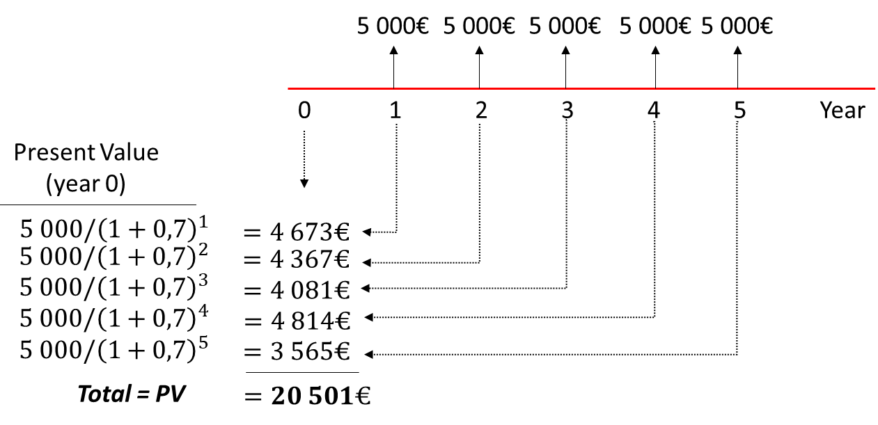
2 method: By using the Present Value of 5-year annuity formula.
$$PV=5 000 \left[\frac{1}{0,7}-\frac{1}{0,7{\left(1+0,7\right)}^{5}}\right]=20 501€$$
- If we discount each cash flow by one less year, the present value is increased by the multiple $(1 + r).$ So, our annuity due is:
$$Annuity due=20 501*\left(1+0,7\right)=21 936€$$

Calculating Annual Payments
Loans from banks are repaid in equal monthly instalments.
$$Loan value=PV=Annual loan payment*t-year annuity factor$$
$$Annual loan payment=\frac{Loan value}{t-year annuity factor}$$
Loans with an ongoing schedule of equal payments are referred to as amortising loans. When a loan is "amortised," it means that a portion of the regular payment is utilised to cover the loan's principal and interest.

Example 6 – Paying Off a Bank loan. Suppose that you take out a four-year loan of 1 000€. The bank requires you to repay the loan evenly over the four years. It must therefore set the four annual payments so that they have a present value of 1 000€. Thus,
$$PV=annual loan payment*4-year annuity factor=1 000€$$
$$Annual loan payment=\frac{1 000€}{4-year annuity factor}$$
Suppose that the interest rate is 10% a year. Then,
$$4-year annuity factor= \left[\frac{1}{0,10}-\frac{1}{0,10*{\left(1+0,10\right)}^{4}}\right]=3,170$$
$$Annual loan payment=\frac{1 000}{3,170}=315,47€$$
At the end of the first year, the interest charge is 10% of 1 000€, or 100€. So, 100€ of first payment is absorbed by interest and the remaining 215,47€ (315,47€ - 100€) is used to reduce the loan balance to 784,53€ (1 000€ - 215,47€). Next calculations are illustrated in Table 1.
Table 1: Calculations of loan payments
Year | Beginning of year balance | Year-end interest on balance | Total year-end | Amortization of loan | End of year balance
1 | loan amount = 1 000 | interest charge = 0,10 * 1 000 = 100 | calculated annuity loan payment = 315,47 | amortization = 315,47 – 100 = 215,47 | 1 000 - 215,47 = 784,53
2 | 784,53 | 0,10 * 784,53 = 78,45 | 315,47 | 315,47 - 78,45 = 237,02 | 784,53 - 237,02 = 547,51
3 | 547,51 | 0,10 * 547,51 = 54,75 | 315,47 | 315,47 - 54,75 = 260,72 | 547,51 - 260,72 = 286,79
4 | 286,79 | 0,10 * 286,79 = 28,68 | 315,47 | 315,47 - 28,68 = 286,79 | 286,79 - 286,79 = 0

Example 7 – Calculating Mortgage Payments. Suppose that you take out a 250 000€ house mortgage from your local savings bank when the interest rate is 12%. The bank requires you to repay the mortgage in equal annual instalments over the next 30 years.
Thus,
$$30-year annuity factor= \left[\frac{1}{0,12}-\frac{1}{0,12 {\left(1+0,12\right)}^{30}}\right]=8,055$$
$$Annual mortgage payment=\frac{250 000}{8,055}=31 036€$$
Table 2: Calculation of mortgage payments
Year | Beginning of year balance | Year-end interest on balance | Total year-end | Ammortizattion of loan | End of year balance
1 | 250 000,00 € | 30 000,00 € | 31 035,91 € | 1 035,91 € | 248 964,09 €
2 | 248 964,09 € | 29 875,69 € | 31 035,91 € | 1 160,22 € | 247 803,86 €
3 | 247 803,86 € | 29 736,46 € | 31 035,91 € | 1 299,45 € | 246 504,41 €
4 | 246 504,41 € | 29 580,53 € | 31 035,91 € | 1 455,39 € | 245 049,03 €
5 | 245 049,03 € | 29 405,88 € | 31 035,91 € | 1 630,03 € | 243 418,99 €
6 | 243 418,99 € | 29 210,28 € | 31 035,91 € | 1 825,64 € | 241 593,36 €
7 | 241 593,36 € | 28 991,20 € | 31 035,91 € | 2 044,71 € | 239 548,65 €
8 | 239 548,65 € | 28 745,84 € | 31 035,91 € | 2 290,08 € | 237 258,57 €
9 | 237 258,57 € | 28 471,03 € | 31 035,91 € | 2 564,89 € | 234 693,69 €
10 | 234 693,69 € | 28 163,24 € | 31 035,91 € | 2 872,67 € | 231 821,01 €
11 | 231 821,01 € | 27 818,52 € | 31 035,91 € | 3 217,39 € | 228 603,62 €
12 | 228 603,62 € | 27 432,43 € | 31 035,91 € | 3 603,48 € | 225 000,14 €
13 | 225 000,14 € | 27 000,02 € | 31 035,91 € | 4 035,90 € | 220 964,24 €
14 | 220 964,24 € | 26 515,71 € | 31 035,91 € | 4 520,21 € | 216 444,04 €
15 | 216 444,04 € | 25 973,28 € | 31 035,91 € | 5 062,63 € | 211 381,41 €
16 | 211 381,41 € | 25 365,77 € | 31 035,91 € | 5 670,15 € | 205 711,26 €
17 | 205 711,26 € | 24 685,35 € | 31 035,91 € | 6 350,56 € | 199 360,70 €
18 | 199 360,70 € | 23 923,28 € | 31 035,91 € | 7 112,63 € | 192 248,07 €
19 | 192 248,07 € | 23 069,77 € | 31 035,91 € | 7 966,15 € | 184 281,92 €
20 | 184 281,92 € | 22 113,83 € | 31 035,91 € | 8 922,08 € | 175 359,84 €
21 | 175 359,84 € | 21 043,18 € | 31 035,91 € | 9 992,73 € | 165 367,10 €
22 | 165 367,10 € | 19 844,05 € | 31 035,91 € | 11 191,86 € | 154 175,24 €
23 | 154 175,24 € | 18 501,03 € | 31 035,91 € | 12 534,89 € | 141 640,36 €
24 | 141 640,36 € | 16 996,84 € | 31 035,91 € | 14 039,07 € | 127 601,29 €
25 | 127 601,29 € | 15 312,15 € | 31 035,91 € | 15 723,76 € | 111 877,53 €
26 | 111 877,53 € | 13 425,30 € | 31 035,91 € | 17 610,61 € | 94 266,91 €
27 | 94 266,91 € | 11 312,03 € | 31 035,91 € | 19 723,88 € | 74 543,03 €
28 | 74 543,03 € | 8 945,16 € | 31 035,91 € | 22 090,75 € | 52 452,28 €
29 | 52 452,28 € | 6 294,27 € | 31 035,91 € | 24 741,64 € | 27 710,64 €
30 | 27 710,64 € | 3 325,28 € | 31 035,91 € | 27 710,64 € | 0,00 €

Future Value of Annuity
Sometimes you have to figure out how much a regular flow of payments will be worth in the future. The general formula for the future value of a level stream of cash flows of 1€ a year for t years is:
$$Future value of annuity=Present value of annuity*{\left(1+r\right)}^{t}==C*\left[ \frac{1}{r} - \frac{1}{r{\left(1+r\right)}^{t}} \right]*{\left(1+r\right)}^{t} =C*\frac{{\left(1+r\right)}^{t}-1}{r}$$
$$FV= C*\frac{{\left(1+r\right)}^{t}-1}{r}$$
This raises a general point. Any series of cash flows whose current value can be determined may always be multiplied by ${\left(1+r\right)}^{t}$ to get their future worth.

Example 8 – Saving to buy a sailboat. Perhaps you've always wanted to own a sailboat; a 40-foot Beneteau would be a great choice. However, that requires some significant financial planning. You predict that after you start working, you will be able to save 20 000€ year from your income and receive an 8% return. How much money will you have left over in 5 years?
First of all we need to calculate the present value of 5-year annuity:
$$PV=20 000* \left[\frac{1}{0,08}-\frac{1}{0,08*{\left(1+0,08\right)}^{5}}\right]=79 854€$$
For calculating the future value we need to multiply present value by ${\left(1+r\right)}^{t}$
$$FV=79 854*{\left(1+0,08\right)}^{5}=117 332€$$
Or we can simply use the formula of future value of annuity:
$$FV= C*\frac{{\left(1+r\right)}^{t}-1}{r}=20 000* \frac{{\left(1+0,08\right)}^{5}-1}{0,08}=20 000*5,866601=117 332€$$

Growing Perpetuities and Annuities

Growing perpetuity
Previous parts were about how to value level streams of cash flows, but you frequently need to value a stream of cash flows that increases steadily. Evaluate your previous intentions to donate 10 billion EUR to the fight against malaria and other infectious diseases. Unfortunately, you ignored to account for the rise in salaries and other expenses, which would most likely average roughly 4% a year beginning in year 1. Therefore, you must contribute 1 billion EUR in year 1, $1,04*1 billion EUR$ in year 2, etc., rather than 1 billion EUR annually in perpetuity. The present value of this stream of cash flows can be calculated as follows if we use the letter "$g$" to represent the cost growth rate.
$$PV=\frac{C_{1}}{1+r}+\frac{C_{2}}{{\left(1+r\right)}^{2}}+\frac{C_{3}}{{\left(1+r\right)}^{3}}+…$$
$$=\frac{C_{1}}{1+r}+\frac{C_{1}(1+g)}{{\left(1+r\right)}^{2}}+\frac{C_{1}{\left(1+g\right)}^{2}}{{\left(1+r\right)}^{3}}+…$$
There is a simple formula for sum of this geometric series. We need to calculate the sum of an infinite geometric series $PV=a(1+x+x^{2}+…)$ where $a=C_{1}/(1+r)$ and $x=(1+g)/(1+r)$. As we showed above, the sum of such a series is $a/(1-x)$. Substituting for $a$ and $x$ in this formula we have:
$$PV of growing perpetuity=\frac{C_{1}}{r-g}$$
As a result, you must set away today's amount in order to create a constant stream of income that keeps up with the rate of expense growth:
$$PV=\frac{C_{1}}{r-g}=\frac{1 billion EUR}{0,10-0,04}=16,667 billion EUR$$

Growing annuity
The present value of a growing annuity formula calculates the present day value of a series of future periodic payments that grow at a proportionate rate. A growing annuity may sometimes be referred to as an increasing annuity. For calculation of the growing annuity we can use the next formula:
$$PV of growing annuity=C*\frac{1}{r-g}\left[1-\frac{{\left(1+g\right)}^{t}}{{\left(1+r\right)}^{t}}\right]$$
The equation collapses if $r = g$. In that instance, the growth of the cash flows is proportional to the amount by which they are discounted. As a result, the present value of each cash flow is equal to $C/(1 + r)$, and the annuity's total present value is equal to $t* C/(1 + r)$. This particular formula is still accurate, though it is still risky, if $r > g$.

Example 9 – Winning Big at the Lottery. In August 2017, a Massachusetts woman invested in a Powerball lottery ticket and won a record 758,7 million EUR. We suspect that she received unsolicited congratulations, good wishes, and requests for money from dozens of more or less worthy charities, relations, and newly devoted friends. In response, she could fairly point out that the prize wasn’t really worth 758,7 million EUR. That sum was to be paid in 30 annual instalments. The payment in the first year was only 11,42 million EUR, but it then increased each year by 5% so that the final payment was 47,00 million EUR. The total amount paid out was 758,7 million, but the winner had to wait to get it. If the interest rate was 2,7%, what was that 758,7 EUR prize really worth?

Suppose that the first payment occurs at the end of year 1, so $C_{1}=11,42 million EUR$. If the payments then grow at the rate of $g=0,05$ each year, the payment in year 2 is $11,42 million EUR*1,05$, and in year 3 it is $11,42 million EUR*{1,05}^{2}$. We can calculate each 30 cash flows and discount them at 2,7% or we can use the formula for the present value of a growing annuity:
$$PV=C*\frac{1}{r-g}\left[1-\frac{{\left(1+g\right)}^{t}}{{\left(1+r\right)}^{t}}\right]=11,42 mil.*\frac{1}{0,027-0,05}\left[1-\frac{{\left(1+0,05\right)}^{30}}{{\left(1+0,027\right)}^{30}}\right]=468 mil. EUR$$
Therefore, 468 million EUR is the present value of a stream of payments that will increase over time and begin at the end of the first year. Since the lottery winner receives the first payment right away (in year 0) and the final payment is received in year 29 as opposed to year 30, the news is actually not all that awful. As a result, we must add $(1 + r)$ to our present value estimate. Therefore, the prize's present value is
$$468 mil*\left(1+0,027\right)= 481 million EUR$$
It would be worth 757,8 million EUR if all of the Powerball winnings were distributed right away. When the prize is paid out over the course of 29 years, it’s worth is reduced to 481 million EUR, which is significantly less than the prize's well-known value but is still a respectable day's take.
Lottery operators typically create provisions so that winners who have significant spending plans can accept an equivalent lump payment. In this case, the winner could choose to get 481 million EUR upfront or the 758,7 million EUR distributed over 30 years. The present value of both agreements was the same.

How interest is paid and quoted
We made the assumption in our examples that cash flows only happen at the end of each year. This occasionally happens. For example, the government pays interest on its bonds each year in France and Germany. Government bonds, however, only accrue interest every two years in the United States and Great Britain. In other words, if a US government bond promises to pay 10% interest year, the investor really receives 5% income every six months.
If the first interest payment is made at the end of six months, you can earn an additional six months’ interest on this payment. For example, if you put 100€ into a bond that pays 10% compound interest every six months, your wealth will increase to 105€ after six months and to 110,25€ after a year if you put that same 100€ into the bond. In other words, a 10% annual interest rate paid semi-annual is the same as a 10,25% annual interest rate. The bond's effective annual interest rate is 10,25%.
Let’s take another example. Let's say a bank offers you a car loan with a 12% annual percentage rate (APR) and monthly interest payments. By this, the bank means that you must pay one-twelfth of the annual rate each month, or $1\%=12/12$. The bank is therefore quoting a rate of 12%, while your loan's effective annual interest rate is ${\left(1+0,01\right)}^{12} - 1 =0,1268 or 12.68\%$.
Our examples show that there is a difference between the yearly interest rate that is quoted and the annual interest rate that is actually being charged. The total annual payment divided by the number of payments made during the year is often used to compute the advertised annual rate. The quoted and actual rates are the same when interest is paid once a year. The effective interest rate is higher than the reported rate when interest is paid more frequently.
In general, if you invest 1€ at a rate of $r$ per year compounded $m$ times a year, your investment at the end of the year will be worth ${\left[1+\left(\frac{r}{m}\right)\right]}^{m}$ and the effective interest rate is ${\left[1+\left(\frac{r}{m}\right)\right]}^{m}-1$.

Continuous Compounding
The rate could be compounded weekly ($m = 52$) or daily ($m = 365$) in place of compounding interest on a monthly or semiannual basis. In fact, there is no limitation on how often interest may be paid. One can envision a scenario in which payments are dispersed uniformly and continuously throughout the year, causing the interest rate to accrue continuously. When we talk about continuous payments, we are pretending that money can be dispensed in a continuous stream like water out of a faucet. One can never quite do this. In this case $m$ is unlimited.
It turns out that continual compounding is useful in many situations in finance. For example, one important application is in option pricing models, such as the Black–Scholes model. These models use continuous time. As a result, you will discover that the constantly compounded interest rate is required by the majority of computer systems used to determine option values.
Finding a constantly compounded interest rate could appear to require a lot of math. But recall your algebra in high school. You might remember that ${\left[1 + \left(\frac{r}{m}\right)\right]}^{m}$ approaches ${\left(2,718\right)}^{r}$ as $m$ approaches infinity. The base for natural logarithms is the number $2,718$, often known as $e$. By the end of the first year, 1€ invested at a constantly compounded rate of $r$ will grow to $e^{r} ={\left(2,718\right)}^{r}$. It will increase until it reaches $e^{rt}= {\left(2,718\right)}^{rt}$ after $t$ years.

Example 10. Suppose you invest 1€ at a continuously compounded rate of 11% ($r = 0,11$) for one year ($t = 1$). The end-year value is $e^{0,11}$, or 1,116€. In other words, investing at 11% a year continuously compounded is exactly the same as investing at 11.6% a year annually compounded.

Example 11. Suppose you invest 1€ at a continuously compounded rate of 11% ($r = 0,11$) for two years ($t = 2$). The final value of the investment is $e^{rt} = e^{(2*0,11)}=e^{0,22}$, or 1,246€.

Sometimes it could be more acceptable to expect that a project's cash flows will be distributed equally throughout the year rather than all coming at once. To handle this, we may easily modify our earlier formulations. For example, suppose that we wish to compute the present value of a perpetuity of $C$ euros a year. We already know that if the payment is made at the end of the year, we divide the payment by the annually compounded rate of $r$:
$$PV=\frac{C}{r}$$
If the same total payment is made in an even stream throughout the year, we use the same formula but substitute the continuously compounded rate.

Example 12. Suppose the annually compounded rate is 18,5%. The present value of a 100€ perpetuity, with each cash flow received at the end of the year, is $100/0,185 = 540,54€$. If the cash flow is received continuously, we must divide 100€ by 17%, because 17% continuously compounded is equivalent to 18,5% annually compounded $(e^{0,17}= 0,185)$. The present value of the continuous cash flow stream is $100/0,17 = 588,24€$. Investors are prepared to pay more for the continuous cash payments because the cash starts to flow in immediately

We must remember that an annuity is simply the difference between a perpetuity received today and a perpetuity received in year $t$. A continuous stream of C euros a year in perpetuity is worth $C/r$, where $r$is the continuously compounded rate. Our annuity, then, is worth
$$PV=\frac{C}{r}-Present value of\frac{C}{r}received in year t$$
Since $r$ is the continuously compounded rate, $C/r$ received in year $t$ is worth$\left(C/r\right)*\left(1/{e^{rt}}\right)$ today. Our annuity formula is therefore
$$PV=\frac{C}{r}-\frac{C}{r}*\frac{1}{e^{rt}} or PV=C\left(\frac{1}{r}-\frac{1}{r}*\frac{1}{e^{rt}}\right)$$
Sometimes it can be rewrite as:
$$PV=\frac{C}{r}(1-e^{rt})$$
Example 13. After you have retired, you plan to spend 200 000€ a year for 20 years. The annually compounded interest rate is 10%. How much must you save by the time you retire to support this spending plan?

Let us first do the calculations assuming that you spend the cash at the end of each year. In this case we can use the simple annuity formula that we derived earlier:
$$PV=C*\left(\frac{1}{r}-\frac{1}{r{\left(1+r\right)}^{t}}\right)=200 000*\left(\frac{1}{0,10}-\frac{1}{0,10*{\left(1+0,10\right)}^{20}}\right)=200 000*8,514=1 702 800€$$
Thus, you will need to have saved 1,7 million by the time you retire.
Instead of waiting until the end of each year before you spend any cash, it is more reasonable to assume that your expenditure will be spread evenly over the year. In this case, instead of using the annually compounded rate of 10%, we must use the continuously compounded rate of $r = 9,53\% (e^{0,0953}=1,10$).
$$PV=C\left(\frac{1}{r}-\frac{1}{r}*\frac{1}{e^{rt}}\right)=200 000*\left(\frac{1}{0,0953}-\frac{1}{0,0953}*\frac{1}{e^{0,0953*20}}\right)= 200 000*\left(\frac{1}{0,0953}-\frac{1}{0,0953}*\frac{1}{6,727}\right)=1 786 400€$$
To support a steady stream of outgoings, you must save an additional 83 600€.

In finance, it's normal to simply need a rough estimation of present value. In some cases, a present value computation inaccuracy of 5% is acceptable. It normally doesn't matter in these situations whether you assume that cash flows happen in a continuous stream or at the end of the year. Other times, accuracy is important, and you must be concerned with the precise frequency of the cash flows.



